# Azure document link: https://learn.microsoft.com/en-us/azure/app-service/manage-custom-dns-buy-domain
# Step-by-Step Guide to Purchasing a Domain with Azure App Service Domain

Now we can purchase domain names on Azure portal. Yes, you read it right, you can purchase domain names for your applications in Azure using App service domain. It is a service offered by Azure to purchase and manage domain names within the platform.
What is App Service Domain?
It is a domain management service provided by Microsoft Azure. It enables you to purchase, manage, and configure custom domain names for your web applications hosted on Azure App Services. With App Service Domain, you don’t need to rely on third-party domain providers. Instead, you can buy and manage your domain directly from within the Azure portal, offering a streamlined and integrated experience for users.
App Service Domains are ideal for those who want to quickly set up a custom domain for their applications and don’t want the complexity of managing DNS settings across different platforms.
Features of App Service Domain:
- Domain Purchase & Management: You can purchase new domain names directly from the Azure portal, eliminating the need to go to an external provider. It simplifies the process of linking the domain to your App Service, making it easier to set up your custom domain.

- Integrated with Azure App Services: App Service Domain integrates seamlessly with Azure App Services, so after you purchase the domain, you can quickly map it to your web app without any complex configurations. Azure’s DNS management is fully integrated into the service, making it much easier to set up SSL certificates, configure custom DNS records, and more.

- DNS Management: After registering a domain, you can manage its DNS records directly from the Azure portal. You can configure common records such as A records, CNAME records, TXT records, and MX records. This unified DNS management allows you to keep all your configuration settings within the Azure portal for easier troubleshooting and maintenance.

- SSL Certificates: App Service Domain automatically provides support for Secure Sockets Layer (SSL) certificates, which help secure the communication between users and your website. Azure offers free SSL certificates for custom domains that are tied to App Services, further simplifying your security needs.

- Domain Renewal: App Service Domains come with automatic renewal options. Once your domain expires, Azure will notify you and provide options for renewal, making it easier to maintain control over your domain without worrying about manual renewals.

- Easy Custom Domain Mapping: After purchasing a domain, you can easily map it to your Azure App Service. Azure provides a simple interface to add and verify custom domains, without needing to configure DNS manually through other domain registrars.
How to buy and configure an App Service Domain:
The prerequisites to buy a domain are you need to create an application using App Service in a public region of Azure. App Service Plan must be of higher tier than free and basic tier. And there should not be any spending limit on your subscription.
Setting up a custom domain with App Service Domain in Azure is a straightforward process. Here’s a step-by-step guide:
- Sign in to the Azure portal at [https://portal.azure.com].
- Navigate to App Services and select your app.
- In the left-hand menu of your app, select Custom domains.
- Select Buy App Service domain.
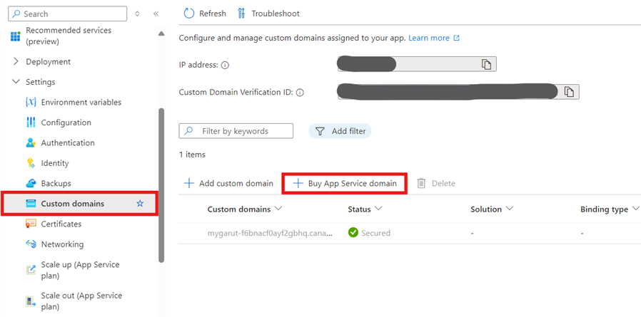
- In the Basics tab, configure the following settings:
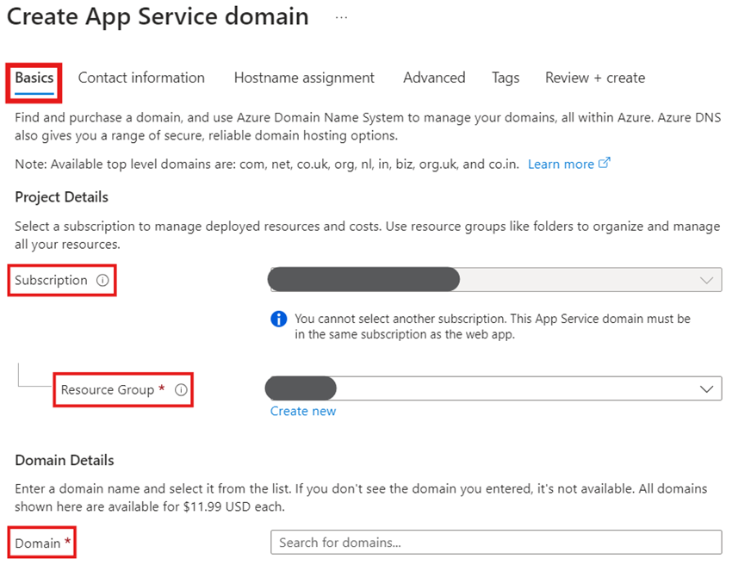
Setting | Description
Subscription | Select the subscription to buy the domain.
Resource Group | Same resource group which your app is in.
Domain | The domain of your choice e.g., example.com. If the domain you’re looking for isn’t available, then select a domain from suggested list or try a different domain.

- Select Next: Contact information and provide your correct and complete information as required by ICANN for the domain registration.
- Select Next: Hostname assignment and verify the default hostnames to map to your app:
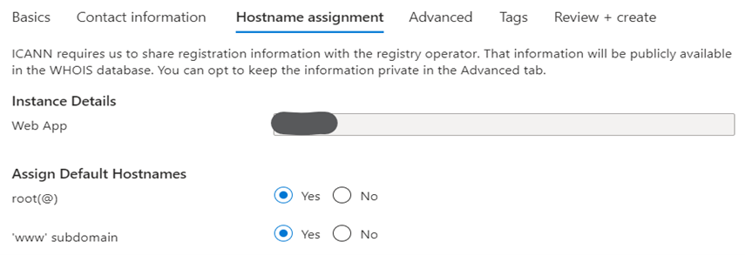
Hostname | Description
root(@) | The root or apex subdomain. If you purchase example.com domain, that’s the root domain. Select No if you don’t want to map the hostname to your app.
‘www’ subdomain | If you purchase the example.com domain, the www subdomain would be www.example.com. Select No if you don’t want to map the hostname to your app.

- Select Next: Advanced and configure the optional settings:
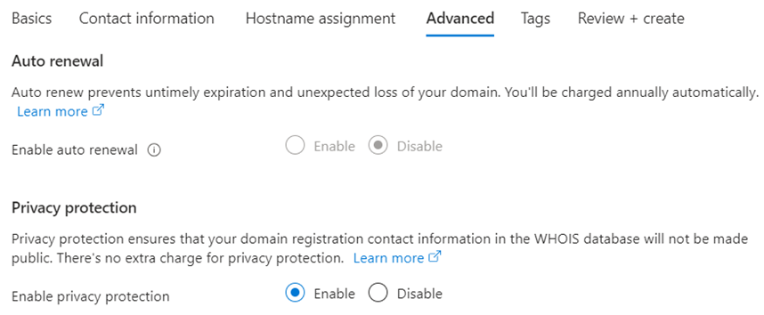
Setting | Description
Auto renewal | This option prevents untimely expiration and unexpected loss of your domain. You will be charged annually automatically from your subscription.
Privacy protection | Enabled by default. It ensures that your contact information in the WHOIS database will not be made public.

- Select Next: Tags and set the tags you want for your App Service domain. Tagging isn’t required, it is optional.
- Select Next: Review + create and review your domain order. When finished, select Create.
- When the domain registration is complete, you see a Go to resource button. Click it to reach the management page.
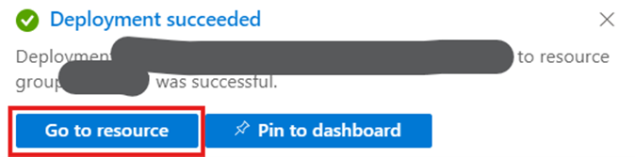
Now you are good to assign this custom domain to an App Service application. After configuration, visit your custom domain (e.g., www.example.com) to ensure that it resolves correctly to your web application. The process can take some time due to DNS propagation, but once everything is set up, your application should be accessible under your custom domain.

